Here using the microcontroller we have calibrated the distance sensor with the RPM of the motor so using the Pulse Width Modulation (PWM) we can control the speed of the vehicle In accordance with the distance of the obstacle in the periphery

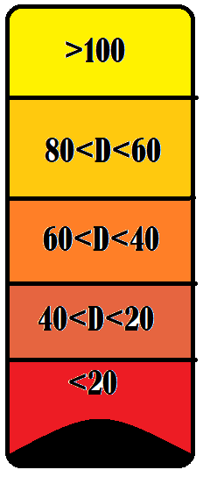

|  |  |
| --- | --- |
| **DISTANCE SCALE (m)** | **MAX SPEED LIMIT ON FULL THROTTLE** |
| >100 | Normal |
| 80>D>60 | 75% |
| 60>D>40 | 50% |
| 40>D>20 | 25% |
| <20 | 0 |

Likewise if the distance is in rage of 80-60 m of moving car that would take just a few second to clash to the obstacle ahead of it then the speed of the car COULD MAXIMUM go on pre decided speed of 75% of max possible speed of car.

So in a way this system is the conclusive representation of how the forward collision is avoided in cars effieintly.

Over it ,event he driver wants to hit the object they can’t.